CAMERA RENTAL APPLCATON:

OUTPUT:

1. LOGIN

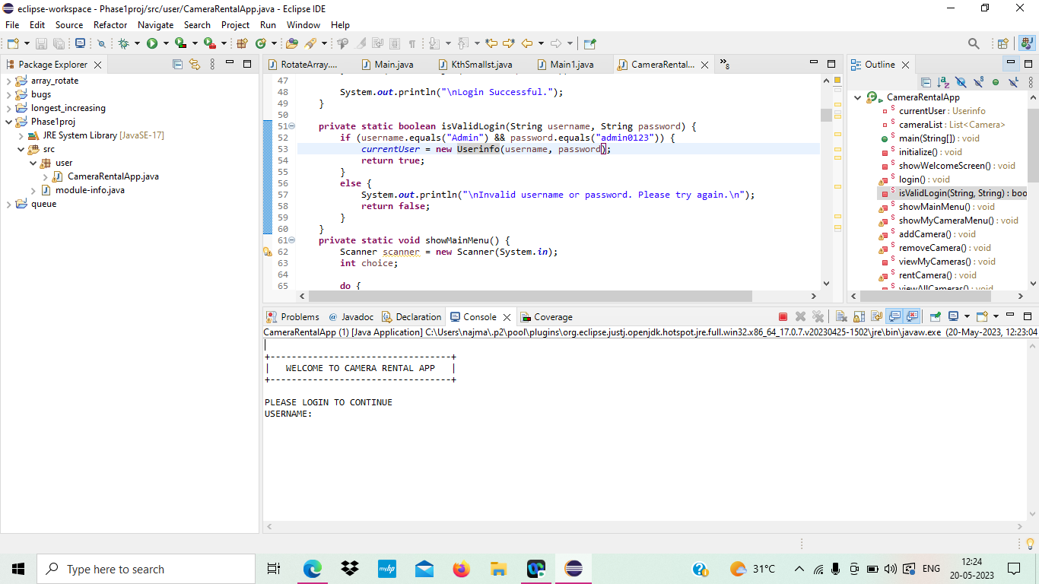

1. OPTIONS TO BE DISPLAYED:

1. ADD CAMERA:

1. REMOVE CAMERA:

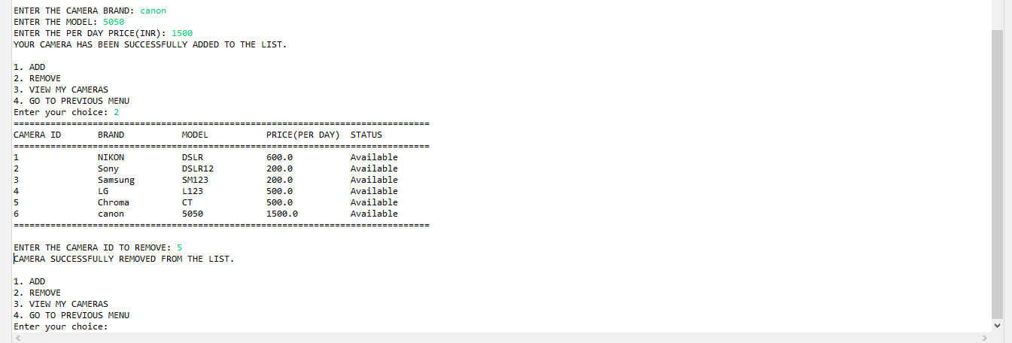

1. RENT A CAMERA:

1. VIEW ALL:

1. MY WALLET OR ADD MONEY:

1. FAILED TRANSACTION:

